Question/Answer Booklet

APPLIED
INFORMATION
TECHNOLOGY

Stage 2 2007

Time allowed for this paper
Reading time before commencing work: ten minutes
Working time for paper: three hours

Materials required/recommended for this paper
To be provided by the supervisor
This Question/Answer Booklet

To be provided by the candidate
Standard items: pens, pencils, eraser or correction fluid, ruler, highlighter

Special items: nil

Important note to candidates
No other items may be taken into the examination room. It is your responsibility to ensure that you do not have any unauthorized notes or other items of non-personal nature in the examination room. If you have any unauthorized material with you, hand it to the supervisor before reading any further.

Structure of this paper

Section | Number of questions available | Number of questions to be attempted | Suggested working time (minutes) | Marks available
Section One  Multiple choice | 20 | 20 | 20 | 20
Section Two  Short Answer Questions | 6 | 6 | 35 | 30
Section Three  Extended Answer Questions | 2 | 2 | 50 | 50
Section Four  Production | 1 | 1 | 75 | 100
Total marks |  |  |  | 200

Instructions to candidates
- The rules for the conduct of Western Australian external examinations are detailed in the TEE/WACE Handbook. Sitting this examination implies that you agree to abide by these rules.

- Answer all questions in the spaces provided in this Question/Answer Paper. You may ask for extra blank paper if is required. If you do use this indicate in the original answer space where the answer is continued. Scrap paper is also available for making notes.

- Marks available for each question are given either at the end of the question.

- It is strongly recommended that you do not use pencil, except in diagrams.

- You should note that the space made available for an answer does not necessarily give any indication of the length of an appropriate answer.

- At the end of the examination, check that your answer has been written in the box provided on the front cover of their Question/Answer paper and any extra paper you used.

Outcomes 2, 3 & 4 are used for this examination paper.

Outcome 2: Understanding Information and Communication Technologies
- Your understanding of the ICT-related concepts, standards and terminology required to select and use appropriate computer software and hardware to achieve information solutions
- Your understanding of the standards and conventions when selecting and using ICT systems to achieve information solutions
- Your understanding of the management, processes, functions, types and relationships between the components of ICT systems required to achieve information solutions.

Outcome 3: Quality of Information Solutions
- Students explore alternatives and use skills, techniques, processes, standards and conventions to achieve information solutions.
- Understand the ICT-related concepts, standards and terminology required to select and use appropriate computer software and hardware to achieve information solutions.
- Understand the standards and conventions when selecting and using ICT systems to achieve information solutions.
- Understand the management, processes, functions, types and relationships between the components of ICT systems required to achieve information solutions.

Outcome 4: Information and Communication Technologies in Society
- Your understanding of the cultural beliefs, values, abilities and ethical position that can impact on the use of ICT
- Your understanding of the benefits and consequences of ICT use in different contexts and how this relates to beliefs, values, abilities and ethical positions
- Your understanding of the consequences of technological developments on social, personal, cultural, physical, economic and ethical structures and environments.

SECTION A: Multiple Choice. Attempt ALL questions
(10 questions = 10 x 1 mark = 10 marks)
Indicate your answer on the separate answer sheet.

1. Which of the following is NOT a method of capturing graphics?

(a) Scanner
(b) Digital camera
(c) Presentation software
(d) Digital video camera

2. Which of the following graphic formats is a vector graphic format?

(a) GIF
(b) JPG
(c) TIF
(d) PCX

3. DPI literally stands for:

(a) Dots per inch
(b) Data per image
(c) Digital print icon
(d) None of the above

4. Which of the following is an area of health and safety when considering technology?

(a) E-commerce
(b) Data integrity
(c) Ergonomics
(d) Teleworking

5. Here is a URL.
http://www.ecu.edu.au/Science/index.htm

What part of the URL is the section “www.ecu.edu.au”

a) Host
b) Protocol
c) Page
d) Path
6. The source country for the URL is:-

a) United States of America
b) Australia
c) Great Britain
d) Austria

7. A web site has the URL http://www.abc.net.au/local/wa /index.html
The first word in the path is:-

a) www.
b) local.
c) wa.
d) index.

8. File names on personal computers have the format “file name.extension”. In Windows 95/98 there is no reasonable limit to the number of characters in the name, but the extension is usually limited to 3 or 4 characters with a specific format that describes the type of the file. e.g. Word files have a DOC extension. Which one of the following files is a sound file?

a) dingdong.wav
b) dingdong.shw
c) dingdong.avi
d) dingdong.mdb

9. Which of the following include extensions purely related to graphics

a) .htm, .bmp, .gif, .sys
b) .com, .bmp, .doc, xls
c) .jpg, .gif, .mov, .doc.
d) .jpg, .gif, .bmp, .tiff

10. When using audio files to insert low sound to gradually amplify to full sound, the effect to use would be?

a) fade out
b) compress
c) invert
d) fade in

END OF MULTIPLE CHOICE
SECTION B: Short Answers. THREE (3) questions.....
ALL QUESTIONS IN THIS SECTION MUST BE ATTEMPTED.
NO CHOICE. (3 questions = 3 x 10 marks – 30 Marks)

Write answer on answer booklet: Include your name and clearly identify which question and section number is being answered

- The business world is the largest user of computers and information systems. Computer systems will undergo many changes as we head into the next century. There are many trends that will affect the information systems of the next millennium. Discuss two trends from each of the following areas:

(a) Equipment
(b) Software
(c) Users

2. Unfortunately computer crime has become part of our daily lives.

(a) Explain what is meant by the term computer crime.
(b) Give three examples of different types of computer crime.
(c) Suggest two techniques that could be employed to help prevent computer crime.

3. Jodie Thorn is a graphic designer who works for a large international media design company. Jodie is a home e-worker - she works mainly from home and only goes into head office when necessary.

(a) Describe what hardware and software equipment Jodie needs and why?
(b) What are some of the advantages and disadvantages of being a home based Graphic Designer?

END OF COMPULSORY QUESTIONS
SECTION C: Extended Answers.
Attempt any TWO (2) questions.
(2 questions = 2 x 30 marks – 60 Marks)
Write answer on answer booklet: Include your name and clearly identify which of the two questions from four is being answered

- Computer Revolution
Ten years ago many ‘experts’ in talking about the computer revolution, predicted that the home would be one place where this revolution would have a significant impact. Visions of computerised homes with all kinds of electronic wizardry at one’s fingertips were conjured up and different sections of society were filled with fear, excitement or just plain curiosity.

Write a short essay that looks at this 10 year old prediction in relation to what you see as the impact of computers in the home today.

OR
- Piracy
After reading the article below, discuss the topic of “Software, Movie & Music Piracy” from a range of viewpoints.

Read the following article
From: The LA Times Newspaper, January 21, 2007 by Lou Dolinar.

"Before the introduction of the compact disc, media was analog - that is, the recording medium for what you saw or heard corresponded, in some way, to the real world. Needles bounced up and down in grooves to produce music, individual photographs gave the appearance of movement as they flickered by a lens on a strip of film.

The CD changed all that. Sound was digitized, or converted into ones and zeros. Originally designed for music, the CD was seized on by the computer industry as a storage and distribution medium for other types of digital data, primarily programs and operating systems, although PCs soon developed the ability to play back music, too.

This was when the piracy problem began. There had always been people who, for fun or profit, taped records for their own use - or resale. Computers suddenly made this process quick and convenient. Early on, a few programmers realized that there was no real obstacle to copying, or ripping, the CD to your hard drive, and playing it from there. Other programmers had developed a system for shrinking audio files with little loss in quality, MP3. As computers got faster, and hard drives got bigger, a CD could be "ripped" to disk in minutes. The copy was essentially a perfect one, due to the inherent ability of computers to check for errors in data transfers. Simultaneously, the number of people with high-speed Internet connections exploded, and services like Napster made it simple to share these ripped CDs with other people".

This piracy, however much fun it was, cost the music industry billions of dollars and destroyed the market for paid-for music among the tech savvy..."

Source: http://www.latimes.com/technology/ny-bzdolinar5059766jan21,1,2465147.column?coll=la-utilities-technology&ctrack=1&cset=true

OR

3. Work Environment
What issues need to be taken into account when considering the placement of computing or office equipment in a work environment.

OR

4. Radio Frequency Identification Device (RFID's)

Read the article below and answer the following questions.

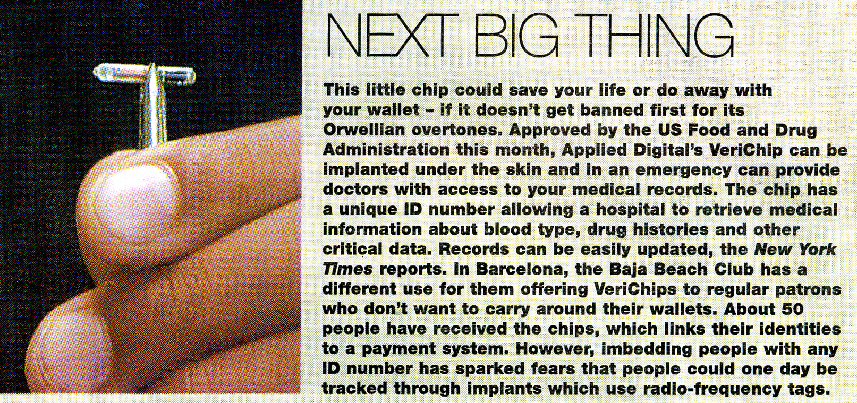

Answer any one of the following (a, b or c):

- What social implications would you consider implanted radio frequency identification device (RFID) chips would have on people that require medical treatment on a regular basis.
- On the privacy of people whom may have criminal intent.
- On any other aspect that you consider to have social implications.

END OF EXAM

